

English's file

- Oral Project p.2

  - Video study 1: Sudden death of a cyclist p.2

- Comprehension p.2
- Expression p.3

  - Video study 2 : Brazilian surfer p.4

- Comprehension p.4
- Expression p.6

  - Video study 3 : An Irish Erasmus Student p.7

- Comprehension p.7
- Expression p.8

- Writing Project p.9

  - Writing Expression : presentation of my sports route p.9

  - Gaelic Football Description p.10

Oral Project

________________________________________________________
Video study n°1
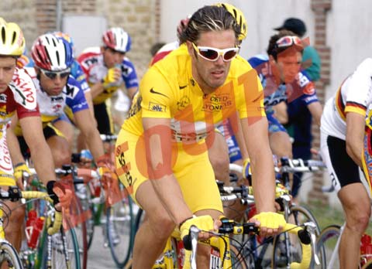 Sudden death of a cyclist 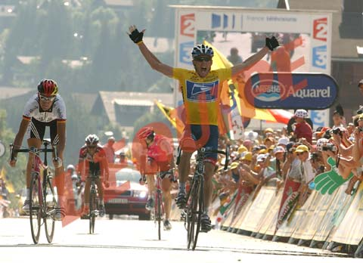
___________________________________________________________________________

Comprehension

1) Identify the document (source, type of document…)

This document is a report extracted from EuroNews’ sports news.

2) What happened?

This report tells us about the death of a 23 years old French cyclist, Fabrice Salanson, found dead by his roommate Sylvain Chavanel in his hotel’s room on the eve of the Tour of Germany. We learn tat he died during his sleep and the causes of his death remain a mystery.

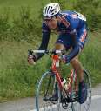

3) How did his team react?

His team Brioches La Boulangère has decided to leave the Tour of Germany and to return to
France.

4) Assessment: Fill in the gaps in this version of the script

Fill in the gaps:

  - mourning
  - 23 years old
  - eve
  - been staying
  - roommate
  - lying
  - wake
  - broke away
  - fine
  - took part
  - forward
  - fellow
  - ???

Expression

Comment on this item and the different aspects of sport.
What could have caused this cyclist death?
Compare competition and sport as a leisure.

- This report tackles an interesting issue: is it normal that a 23 years old professional cyclist, supposed to be fine and perfectly healthy dye in his sleep? The first thing we think concerning the reason of his death is obviously doping giving the numerous cases that this sport has known throughout the time. Doping is a widespread practice in the world of cycling and we logically wonder if it is not the cause of Fabrice Salanson’s death. The take of dope products could have cause an anomaly in his body functioning and his death. Rejecting the theory of doping, the cause of his death could be natural and Fabrice Salanson could have been a victim of the sudden death phenomenon. The autopsy has concluded that his death was natural and linked to a heart failure but doubts hang over.

- Competition and leisure are two different ways to see and practice sport. The goals are different. When you practice a sport as leisure, the aims are to keep yourself in good condition, to share a good moment with people or to have fun whereas the concept of competition is more associated with performance. A competitor looks for results and surpassing of himself. The notion of pleasure is not necessarily the most important. In order to be effective, a competitor must suffer, work and train hard to be successful and to reach a goal.

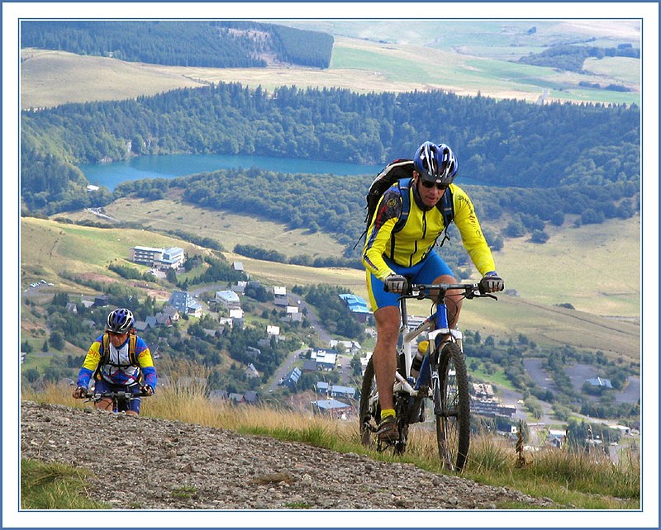

___________________________________________________________________________

Video study n°2
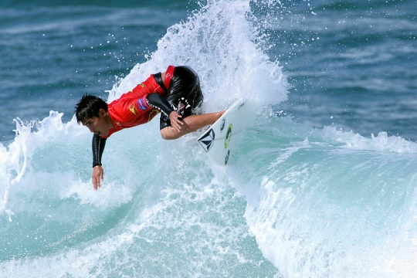 BRAZILIAN SURFER
___________________________________________________________________________

Comprehension

1) Identify the document (Type, subject)

This document is a report from EuroNews dealing with a new world record set by a 20 years old Brazilian surfer on the Amazon River surfing championship. Adailton Mariano surfed during more than 34 minutes on a 5 metres high wave.

2) What does the surfer say?

Adailton Mariano says that: “"I had a moment when l almost disappeared into the wave. I recovered and thank God I was able to overcome my limitations and take maximum advantage of the wave.”

3) Why does the Amazon's giant wave attract surfers?
The Amazon’s giant wave attracts surfers because it is a worldwide unique phenomenon. Two currents push across each other and the result is a 5 metres wave that appears every 12 hours and breaks during kilometres, offering an amazing playground for surfers from all around the world. It occurs at the mouth of the river where river water meets the Atlantic Ocean. The phenomenon is best seen in February and March, where waves up to 4 meters rolling for up to 35 minutes have been observed.
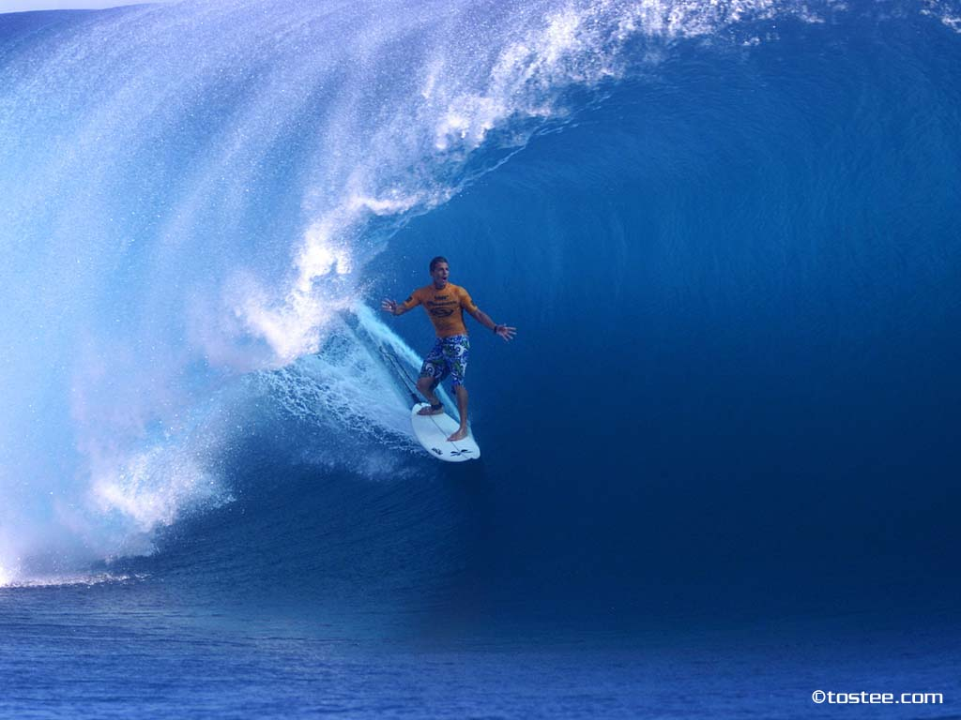
The wave has become popular with surfers. Since 1999, an annual championship has been held in São Domingos do Capim. However, surfing the wave, known as Pororoca, is especially dangerous, as the water contains a significant amount of debris from the margins of the river (often, entire trees).
4) Assessment: Fill in the gaps in this version of the script.

- 20 years old
  - set
  - around 20
  - 34
  - 5
  - ???
  - had
  - 19
  - disappeared
  - overcome
  - known
  - from around the world
  - each other
  - strengthen
  - 12

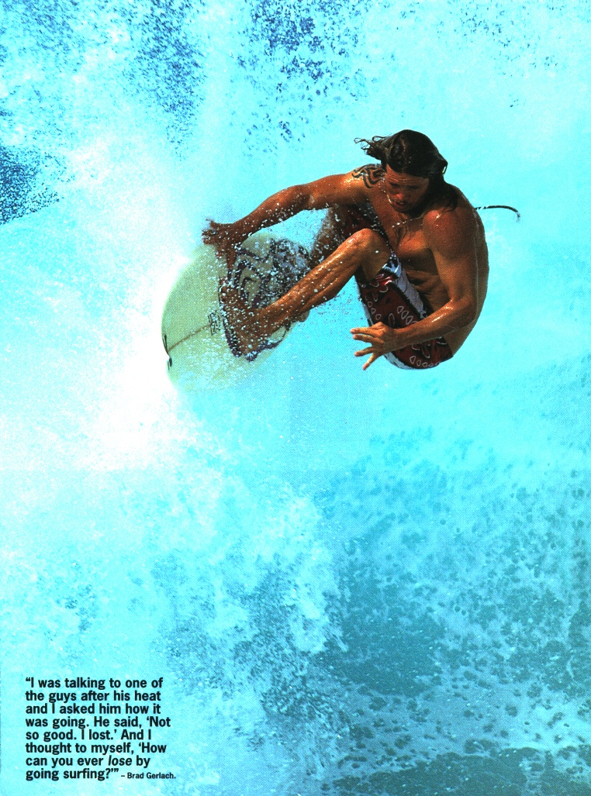

Expression

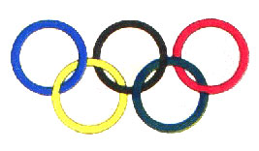

Imagine you welcome an athlete in the Olympic village.
In your opinion, what makes someone a champion? Is it the most important thing in sports? What makes winning so great? What can be learnt from defeat? Tell a story about a victory or a defeat...

- Imagine you welcome an athlete in the Olympic village:
Welcome in your Olympic village’s apartment Mister Lewis. First of all, I give you your keys and your Olympic identity card which will permit you to have an all access in the residential zone and the entire Olympic area. You can use the phone to contact the meet and greet service and hostesses will answer your questions calling 1. To contact the first-aid station, call 911. You will find a village plan on the door and a shuffle will take you at 8 p.m. to have dinner. Near the restaurant, you will see the Olympic center where you will find shops, cinemas, hair salons and cash dispensers. I wish you a good stay in our city and good time in the Olympic precinct Mister Lewis.

- In my opinion, a champion is made of talent, performance, fair-play and charisma. All these elements mixed give birth to a champion. The charisma is very important because a sportsman without personality, positive behaviour or flash of inspiration cannot be a champion. A champion is not necessarily the best but the one who can show magnanimity and nobility of soul in a given situation. Of course, without a minimum of good results, the status of champion is hard to reach but I think that the most important to be a champion is the behaviour on and out of the field. Champions play an important part in sport because they are always considered as examples for people and young generations and they stand for a source of inspiration. With a great champion, a sport has more chances to be popular. The champion also represents emulation and it is positive because it drives people to surpass themselves to reach the champion’s level to be, one day, the champion.

- Winning is an incredible feeling because it is one the best examples of achievements and success provides happiness. Winning is associated with joy and represents the fulfilment of hours of work, training and efforts. When you win, you reach a goal. To win is to share something with your team mates or your staff, to live an adventure till the end, to fulfil a dream and that is why it is so great.
On the other hand, defeat is not always a bad thing. The defeat learns to correct errors and permits to realize the work to do to win. Defeats permit to set the record straight and offer the possibility for sportsmen to be aware of what did not work and to improve themselves. For example, the French football team lost in the semi final in the European championship in 1996 against Czech Republic but this defeat was a good lesson and brought lots of experience to players and staff. They lost but the defeat permitted to not reproduce the same mistakes two years after in the management of the competition, in 1998, during the World Cup. Result: France was world champion and the defeat two years before was the first step of this success.

Video study n°3
 AN IRISH ERASMUS STUDENT

Comprehension

1) What do you learn about this Erasmus student? (Studies, reasons he came to France for a year, how he copes with French lessons...)
The interview brings us several information about Alton, an Erasmus student. He studied 3 years at the University of Dublin in computer sciences. Previously he studied in 2 French universities: in the INSA of Lyon and an other in Nancy. They are approximately 150 at present in his promotion in Dublin. Little many of eleves want to learn in another language in « computer science », because that’s all in English. The reasons for which he came one year to study in Lyon are to discover new ways of life, a new culture.
2) What do you learn about studies and life on a campus in Dublin?
The life on the campus is much more different, it is particular. An effect of “socialisation” was much more felt in Ireland that in France. People enjoyed more the life in community in Ireland, The work to be supplied is different in France, We work more : more working hours (We begin at 8 am in the morning, contrary to Dublin where the courses are more restricted, we begin at 10 am), “it’s more relax”. Schedules allow the students to go out more. Alton compares egally the differents methods of work following universities. The French system settles down completely in the logic of «the university ", But in Ireland the personal work is doubtless more important, they work more "at home".
3) What do You learn about life in Ireland?
The life’s climate in Lyon is more relaxant than in Paris for example Where he passed 3 weeks: in the capital, people seem more busy by their work.
One of the differences between Dublin and France concerns « Sunday »: In Lyon everything is closed in this day while in Dublin Sunday is a day as the others, all the supermarkets are opened. Otherwise in the week, Shops close early in France contrary to the hypermarkets of Dublin which are opened 24/24.
In the same way, there are more coffees, clubs or pubs to relax in Ireland…It is highly-rated more pleasant to live in Ireland.

Personal expression
Why is it interesting to travel? Tell me about a journey (great and bad memories) or your plans to travel.
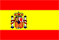
For this personal expression I am going to take the example of my last journey in Spain in the Catalan capital: Barcelona, where I stayed 3 weeks.
I was welcomed by a Spanish family within the framework of an international stay, this one was very instructive to my taste. The stay decomposed between visits and class of Spanish. Every day I was able to discover more enjoyments of the Catalan life. This stay allowed me at first to discover a new country, a new language, new ways of life. Then in a second time, I was able to get acquainted with the local culture within my family of reception but also …

Have the possibility become soaked of the culture of the country in a context as this one was formidable. Barcelona possesses an immense cultural inheritance, the former art in the modern sculptures. The numerous visits which I was able to make: “las ramblas , Dali, Picasso museum, park Guell, the sagrada familia or still " el camp nou ", learnt me uncountable things.

I also left to the discovery of the surroundings. Catalonia can offer more that to have Barcelona in capital. Although Catalonia is not very big, it has however an impressive variety of landscape and different cities. Pyrenees, along the French border, magnificent beaches of Costa Dorada and Costa Brava, as well as towns have me to give the envy to stay there and to take advantage so of the peace in contrast of " Barcelona the Noisy ".
Finally, concerning the rytes of life, in comparison to France, I was able to notice that Spanish lived on schedules different: they eat later. Spanish are in the habit of eating very late. Usually, they lunch to the restaurant only between 2 pm and 4 pm in the afternoon and for the dinner, that from 21 hours. It is only from 21 hours when restaurants open their doors to close that from midnight. It is necessary to know that go out in night club before midnight isn’t usefull, because the inhabitants of Barcelona never go out before.

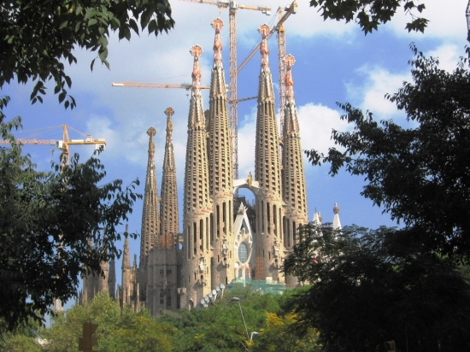

Writing Project
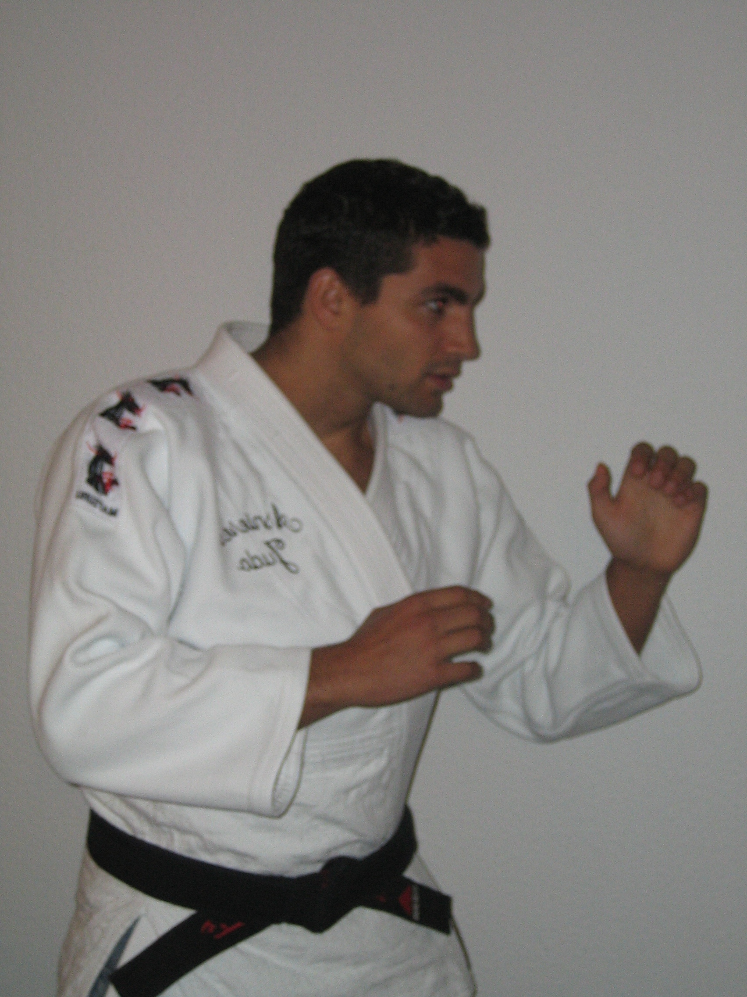 Presentation of my sports’ route 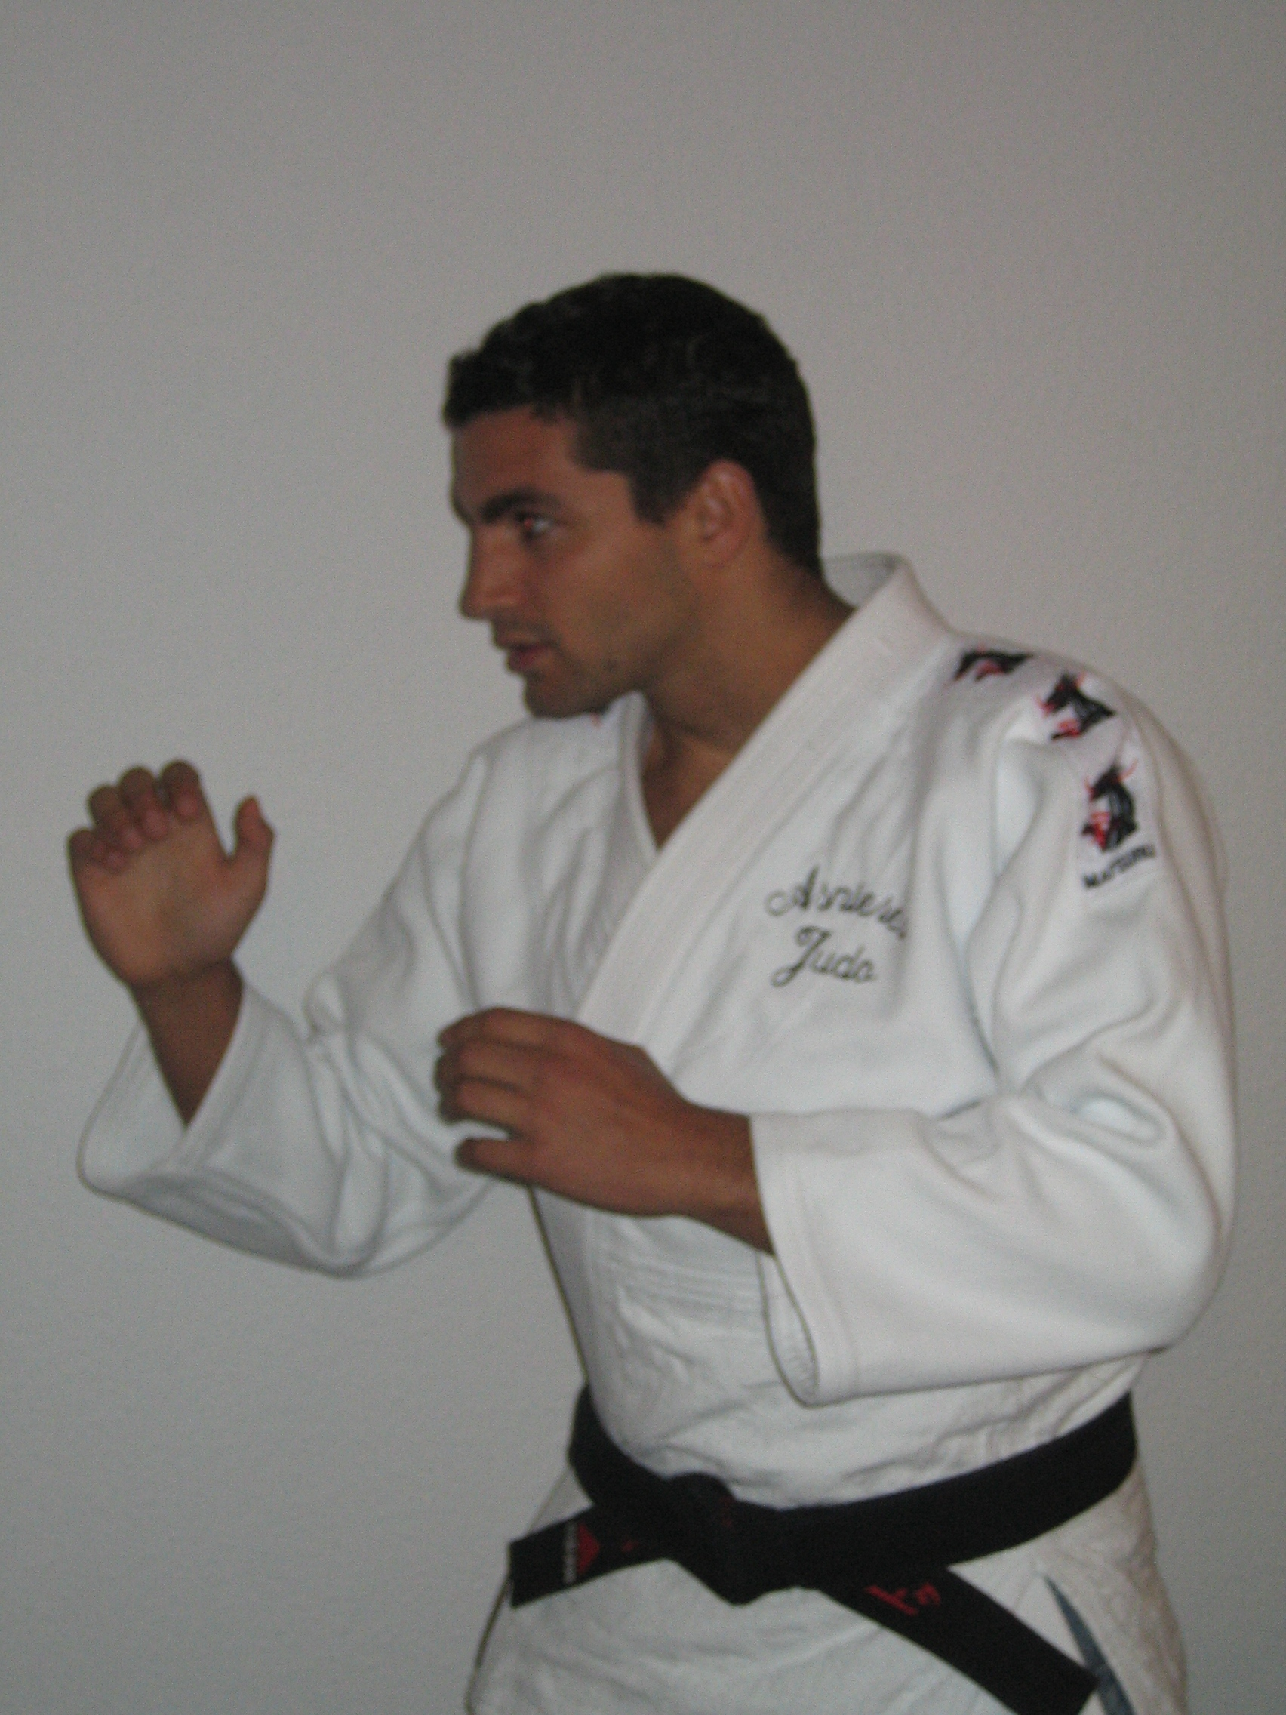

I am involved in the world of the sport since my youngest age. What brought me logically to follow studies on the sciences and the techniques of the physical and sports activities. I wished to become physical education’s teacher but further to the suppression of the posts in France I chose to transfer in the field of the sports management here in Lyon.
Effectively, I began sport since my youngest age: I began the judo in the age of 4 years old and I never stopped doing it. I joined the Racing club of France (in Paris) in 1996 and became champion of France with the junior team in 2003 and 5th in 2004. Before I had integrated the “Pole France Orleans Judo” in 2000 and a bit later the “French team cadet”, I was sixteen years old and I could participate to some stages with the INSEP (the national institute of sport in France). The same year I graduated black belt. This year I’m in a new club classified in first division named “Asnieres” in Parisian suburb and I’m classified 7th in the French 2nd division. My objective for this year is to get to individual first division, which regroups the 15th best French judokas.
While I was practising judo I was also appreciated other sports like rugby, tennis or swimming. Every 4 years during the Olympic Games I remain whole days Scotch-taped in front of the television it is abominable! This evenement is the occasion for me to appreciate completely the beauty of sport.

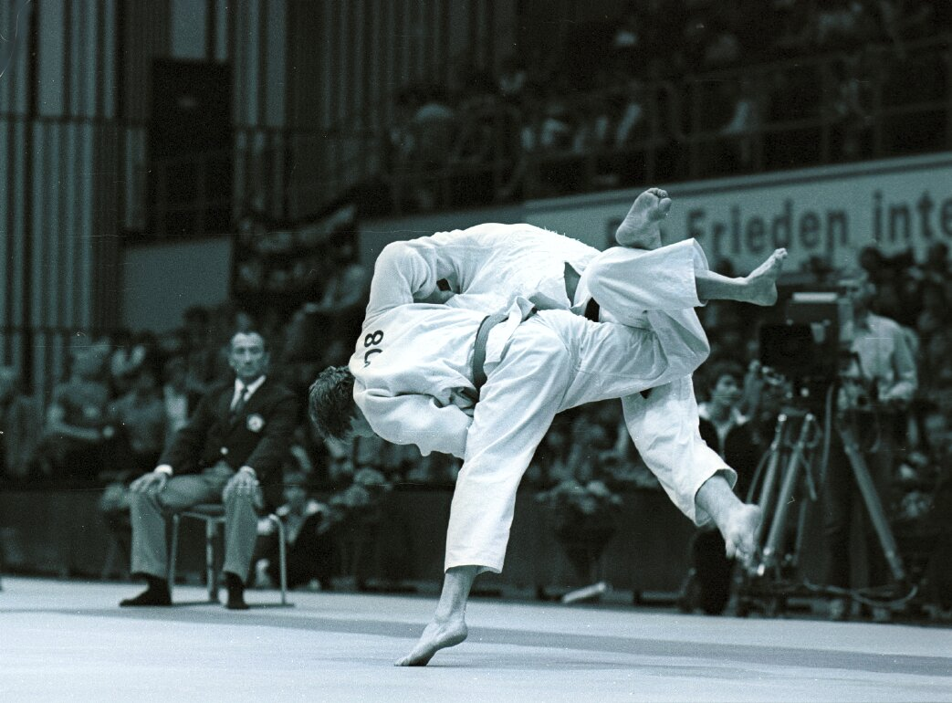

Description of Gaelic football


Gaelic Football, Old of more than a century (appeared in 1885) is one of the Ireland's national sports and it is traditionally only played in Ireland. As a sport it is a bit like a mixture of soccer and rugby, gets closer rather to the Australian football.

A Gaelic football is round, slightly smaller than a soccer ball and it is made of leather, a size 5 football is used for men's Gaelic and a slightly
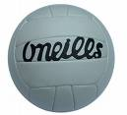

smaller size 4 is used for ladies. In Gaelic Football you can carry the ball in your hands for four steps and then you can bounce it once carry it four more steps and you need to solo (pass it from your foot back to yourself) or else pass the ball. You can either kick the ball from your hands or you can fist pass it (striking the ball with the hand or fist).



A team accounts 15 players on the ground. There is a goal keeper, 6 defenders, 2 midfielders and 6 forwards. The Gaelic football is practised as well by women as by men.

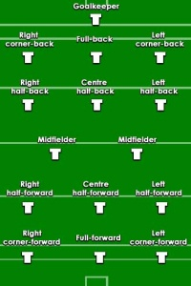

Championship matches owed 70 minutes, and those of league 60 minutes. In Ireland, the championship quarrels from May till September, and the league during the coldest season. The championship is the most prestigious competition and ends by All-Ireland Final, played at Croke Park (Dublin). The winner takes away the Sam Maguire Cup, one of the most prestigious trophee.

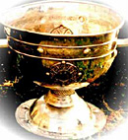

http://www.gaa.ie/index.html

